Periodic Table Trends
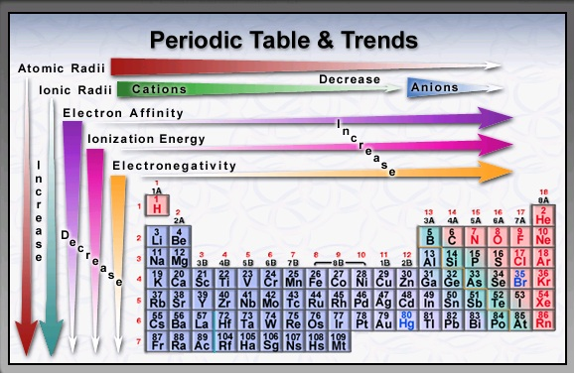
Atomic Radius
- Increases at it moves down a group
- Decreases as it moves from the left to the right in a period
Ionization Energy
- Increases as it moves up a group and from left to right in a period
Electron Affinity
- Increases as it moves up a group and from left to right in a period
Electronegativity
- Increases as it moves up a group and from left to right in a period
- Noble gases have zero electronegativity
Atomic Mass
- Increases from left to right on the periods and from top to bottom in a group

Reactivity
- Metals and non-metals have separate trends. Metal’s reactivity increases as you move down a group and generally decreases as you move left to right across a period.
- Non-metals are less reactive as you move down a group and reactivity generally increases moving left to right.
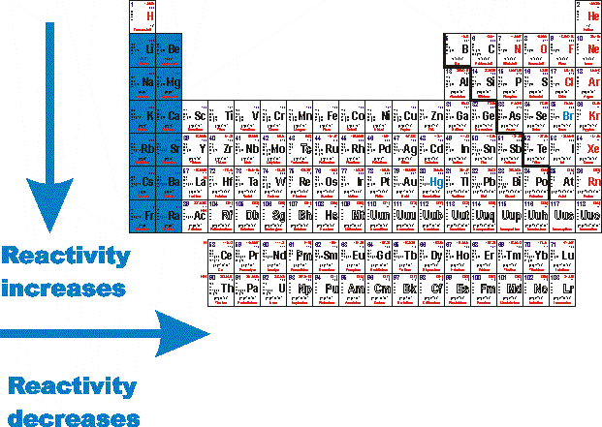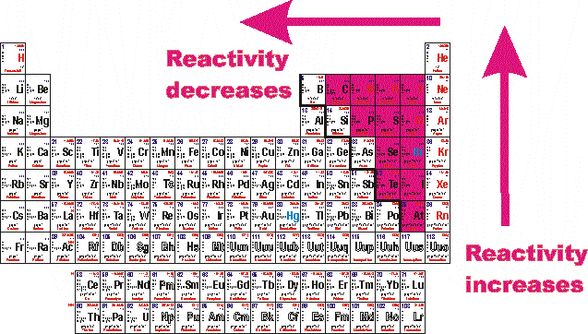
Note:
*Melting points and Density have no set trends

